УО «Белорусский государственный университет информатики и радиоэлектроники»

Кафедра ПОИТ

Отчет по лабораторной работе №1.4

по предмету «Основы алгоритмизации и программирования»

Вариант 20

Выполнил:

Егоров А.С.

Гр. 351005

Проверил:

Данилова Г. В.

Минск 2023

**Задание:**

Дан массив а, состоящий из n-элементов. Получить массив b, где bk=2ak+k.

**Код программы Delphi:**

Program Exercise4;

Uses

System.SysUtils;

// initialization

Var

N: Integer = 0;

List1: Array Of Integer;

List2: Array Of Integer;

Number: Integer = 0;

// Low numbers for loops

I: Integer;

// Flag for end loop for inputted symbols

GoodFlag: Boolean = False;

Begin

// output the task

Write('Program outputs a new array, by using data entered');

Writeln('array, according to this formula b[k]=2 * a[k]+k.');

Writeln;

// loop for check inputted size

Repeat

Try

// input

Writeln('Enter size of array: ');

Readln(N);

If N < 1 Then

Raise Exception.Create('N cannot be less than 1');

GoodFlag := True; // to exit the loop if user entered correct size

Except

On E: Exception Do

Begin

Write(E.Message);

Writeln('!!! Try again.');

End;

End;

Until (GoodFlag);

// memory allocation of the first array

SetLength(List1, N);

// output more info

Writeln('Enter numbers, which you want to add in array:');

// loop for check inputted numbers in array

GoodFlag := False;

Repeat

Try

For I := 0 To N - 1 Do

Begin

Writeln('Enter ', I + 1, ' number: ');

Readln(Number);

List1[I] := Number;

End;

GoodFlag := True; // to exit the loop if user entered correct size

Except

On E: Exception Do

Begin

Write(E.Message);

Writeln('!!! Try again.');

End;

End;

Until (GoodFlag);

// main block

SetLength(List2, N);

For I := 0 To N - 1 Do

Begin

List2[I] := List1[I] * 2 + I + 1;

End;

// output

Writeln('Array after transformation:');

For I := 0 To N - 1 Do

Begin

Write('Number ', I + 1);

Writeln(' in array: ', List2[I]);

End;

// free memory

List1 := Nil;

List2 := Nil;

// freeze console

Writeln('Press enter to exit...');

Readln;

End.

**Код программы С++:**

#include <iostream>

int main()

{

//initialization

int n = 0;

int* list1 = nullptr;

bool goodFlag = false;

// output the task

std::cout << "Program outputs a new array, by using data entered"

<< " array, according to this formula b[k]=2 * a[k]+k.\n";

// loop for check inputted size

do

{

try

{

std::cout << "Enter size of array:\n";

std::cin >> n;

if (std::cin.get() != '\n')

{

std::cin.clear();

std::cin.ignore(35125, '\n');

throw std::exception("Invalid type!!!");

}

if (n < 1)

throw std::exception("N cannot be less than 1!!!");

goodFlag = true; // to exit the loop if user entered correct size

}

catch (const std::exception& ex)

{

std::cout << ex.what() << " Try again.\n";

}

} while (!goodFlag);

// memory allocation of the first array

list1 = new int[n];

// output more info

std::cout << "Enter numbers, which you want to add in array:\n";

// loop for check inputted numbers in array

goodFlag = false;

do

{

try

{

for (int i = 0; i < n; i++)

{

int number = 0;

std::cout << "Enter " << i + 1 << " number:\n";

std::cin >> number;

if (std::cin.get() != '\n')

{

std::cin.clear();

std::cin.ignore(35125, '\n');

throw std::exception("Invalid type!!!");

}

*(list1 + i) = number;

}

goodFlag = true; // to exit the loop if user entered correct numbers

}

catch (const std::exception& ex)

{

std::cout << ex.what() << " Try again.\n";

}

} while (!goodFlag);

//main block

int* list2 = new int[n];

for (int i = 0; i < n; i++)

{

//all good! If u have warning, don't pay attantion to the warning

*(list2 + i) = *(list1 + i) * 2 + i + 1;

}

delete[] list1; // free allocated memory

list1 = nullptr; // do to avoid unsave piece of memory and to avoid RTError

//output

std::cout << "Array after transformation:\n";

for (int i = 0; i < n; i++)

{

std::cout << "Number " << i + 1 << " in array: " << *(list2 + i) << std::endl;

}

delete[] list2;// free allocated memory

list2 = nullptr; // do to avoid unsave piece of memory and to avoid RTError

return 0;

}

**Код программы Java:**

import java.util.Scanner;  
  
  
public class Main {  
 public static void main(String[] args) {  
 //initialization  
 int n = 0;  
 int[] list1 = null;  
 boolean goodFlag = false;  
 //output the task  
 System.out.println("Program outputs a new array, by using data entered" +  
 " array, according to this formula b[k]=2 * a[k]+k.");  
 Scanner in = new Scanner(System.in);  
 // loop for check inputted size  
 do {  
 try  
 {  
 //input  
 System.out.println("Enter size of array:");  
 n = Integer.parseInt(in.nextLine());  
 //check if input is wrong or less than 1  
 if (n < 1)  
 {  
 System.out.print("N cannot be less than 1!!!");  
 throw new Exception();  
 }  
 goodFlag = true; // to exit the loop if user entered correct numbers  
 }  
 catch (Exception ex)  
 {  
 if (ex.getMessage() != null)  
 System.out.print("Invalid type!!!");  
 System.out.println(" Try again.");  
 }  
 } while(!goodFlag);  
 // memory allocation of the first array  
 list1 = new int[n];  
 // output more info  
 System.out.println("Enter numbers, which you want to add in array:");  
 // loop for check inputted numbers in array  
 goodFlag = false;  
 do {  
 try  
 {  
 for (int i = 0; i < n; i++)  
 {  
 System.out.println("Enter " + (i+1) + " number: ");  
 int number = Integer.parseInt(in.nextLine());  
 list1[i] = number;  
 }  
 goodFlag = true; // to exit the loop if user entered correct numbers  
 }  
 catch (Exception ex)  
 {  
 System.out.println("Invalid type!!! Try again.");  
 }  
 }while(!goodFlag);  
 //closing the input  
 in.close();  
 //main block  
 int[] list2 = new int[n];  
 for (int i = 0; i < n; i++)  
 {  
 list2[i] = list1[i] * 2 + i + 1;  
 }  
 //output  
 for (int i = 0; i < n; i++)  
 {  
 System.out.printf("Number %d in array: %d\n",i+1,list2[i]);  
 }  
 }  
}

**Скриншоты:**

**Delphi:**

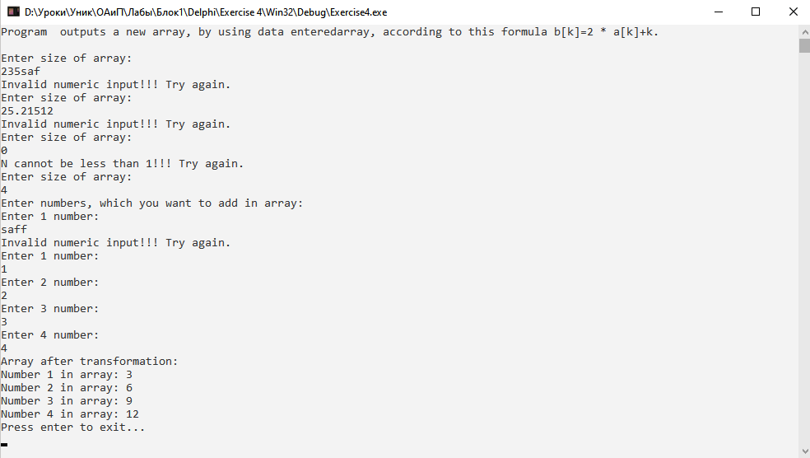

**C++:**

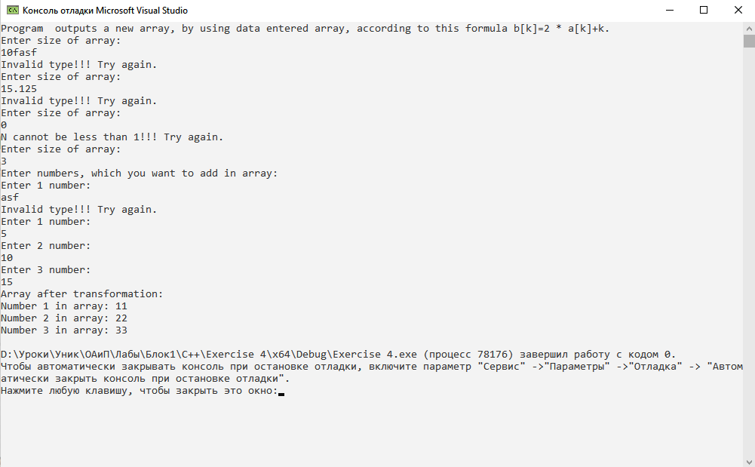

**Java:**

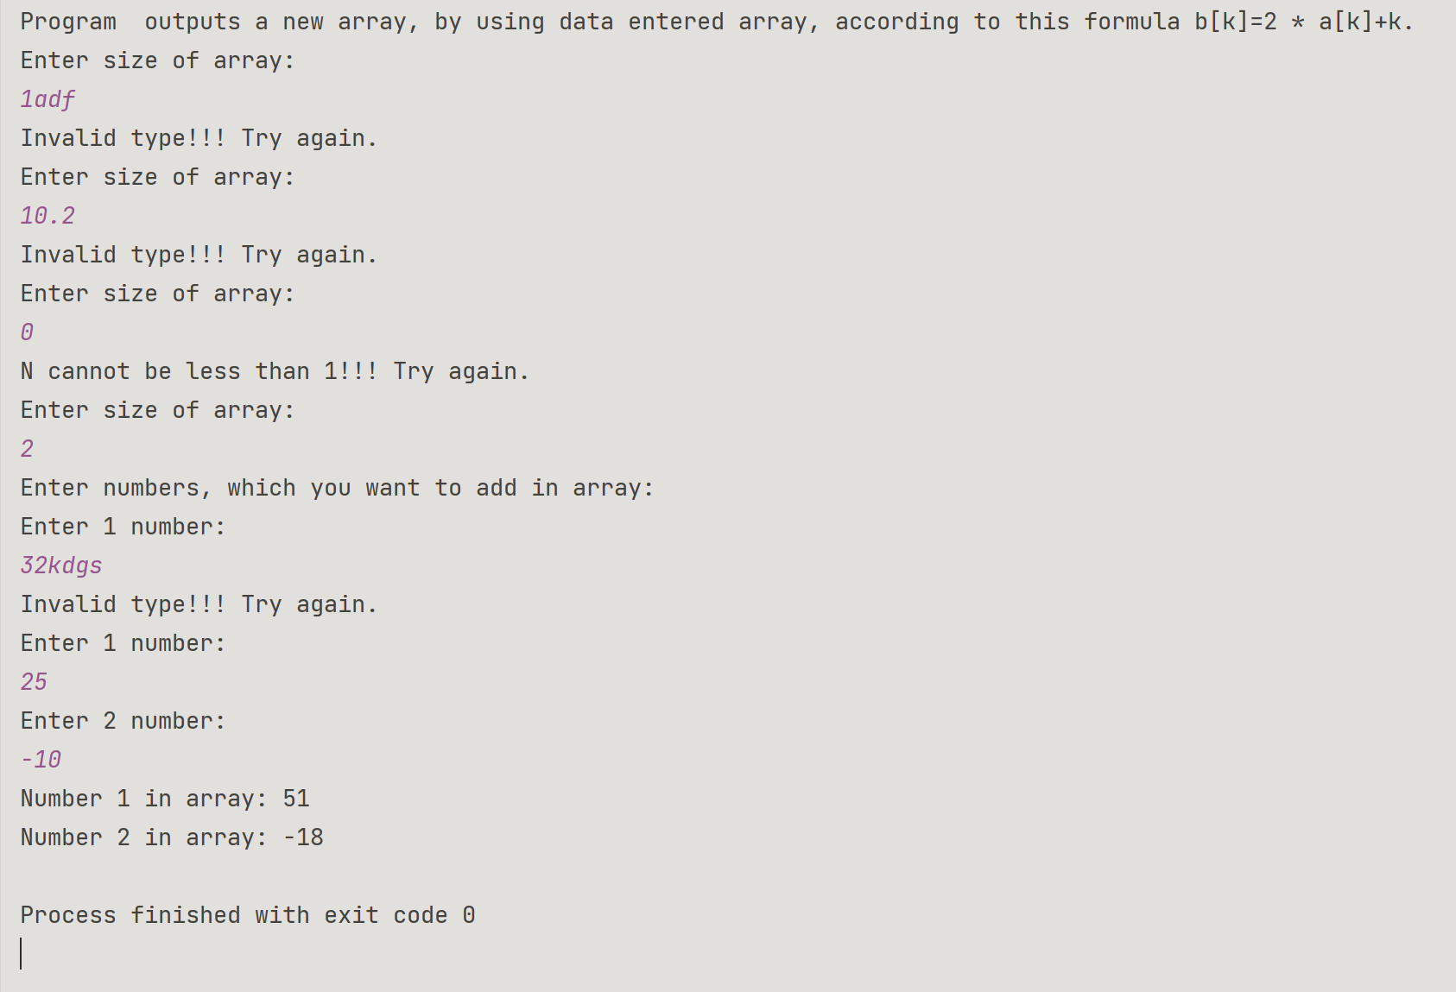

**Блок-схема:**

